 | 上海且华虚拟仪器技术有限公司

SHANGHAI QIEHUA VIRTUALINSTRUMEN CO.,LTD
中国上海市斜土路1480弄33号新徐汇商务楼211室 邮编：200032
TEL：86-21-34160886 FEX：86-21-64181245 Http://www.mtc312.com

Latest development of electromagnetic inspection
of steel wire ropes in China

Xin-hua, DONG Chi-ping, LAI
Shanghai Qiehua virtual instrument Co.,Ltd
211 Room New Xuhui business buiding33House1480 Xietu Road Shanghai China 200032

Abstract
Wire rope inspection has progressed rapidly over the past few years, however, traditional visual inspection is still commonly practiced in most circumstances even though electromagnetic inspection was developed several decades ago. In China, the commencement of electromagnetic technology is comparatively behind other developed countries; nevertheless, based on achievements and experiences of former developers, the development of electromagnetic technology in China is progressing speedily.
Here will illustrate some of the breakthroughs of electromagnetic technology in China and they are: 1) Amalgamation of LF and LMA testing within one device.
2) Acquisition of data directly from sensor by using laptop computer.
3) User friendly interface to enhance more people to use the instrument.
4) Light weight to facilitate on site inspection. Furthermore, here will also compare the differences between China developed instruments and other NDT devices to enhance further understandings.

Keyword

Electromagnetic, Virtual, Online System, Wire Rope

A. Background
The tigers Ate A man
The tourist coach for Shanghai Wild Animal Park broke down on the way on 17th November 1999 when tractor truck went to drag, the wire rope connected the vehicles burst apart by force with the internal serious corrosion and without use for long time. The driver got off to examine rashly. But the driver was bitten the ground by six young tigers.

The Angry Big Bridge
The cable-stayed in Shanghai YangPu Bridge stranded to beat opposite each other. The bridge vibrated violently at midnight 13th September 2000. After thorough research new discovering was influenced by rainy vibration descend the original design service life of the cable form 30 year to 10 years. For this, new-build Shanghai LuPu Bridge adopted the trinity design for suspension, stayed-cable, and arch.

The Doctor Pass Away
Shanghai HuDong Shipyard Slung to install the lifting beam of gantry with 600 ton on 16th July 2001.Hointing support collapsed for slung wire rope broken. There were 36 persons dead for partaking in installation with doctor, professor and workers of factory of Shanghai

TongJi University
In view of the living example, the greater part of the major accident, frequently occurring accident, malignant accidents that happen at scene are caused by wire ropes burst apart suddenly.
A statistical analysis made in US of over 8,000 Laboratory and field test records revealed some interesting facts (the accident rate) on the condition of wire ropes in services:
Accident potential failure:
Approximately 10 percent of all ropes considered showed there are still potentially hazardous.
Accident busting
More than 2 percent of the ropes were in the extremely dangerous condition.

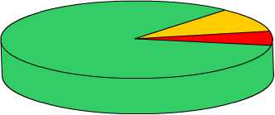
10%
2%
2%
Fig.1 the results of the Statistical analysis

But more than 70 percent of all ropes in the sample were removed form service with little or no strength loss, this finding suggests that only Avery small percentage of all ropes was replaced in a timely manner. The waste are enormous!
a. Traditional Testing methods
The wire ropes have been used since 1934. In order to safe, the people detected with eyes only. In 1906, South Africa invented the first elector magnetic no destructive inspection device of steel wire ropes, with the development of the science, the testing instrument have come out form generation to generation.
Because the structures of the wire ropes are very specifically, they are continual length. The traditional testing methods do not judge accurately. There’s no time to deal with the signal of the high-speed collection in particular. So the missing and mistaken testing is occurred frequently. The results with the best instrument testing can be only qualitative. It can’t be quantitative and can’t popularize use for the difficult operations.

b. Manual Examination
So far people have had to use the oldest wire ropes testing method, namely, the people watch with own eyes, feel by hand and measure on ruler. The internal broken wire flaw can’t be seen certainly. A long-long wire ropes test in this way. The inevitable results are the high laboring intensity, the more random factors, and the lower reliability
c. Offline Examination
Existing Trade Wire Ropes safety supervision stations have to cut a section of the wire ropes to proceed the breaking tensile offline of draw out a single wire rope out of work for draw, curve, twist, According to these test, the people conjecture the safety of the whole wire ropes. This isn’t overall without doubt.
d. Early Disposal
Possessing economic strength manager for safe often adopt to move up announcing invalidated check in paper with the methods of the wire ropes. Some certain companies of public organizations are hoisted the key device, the wire ropes are used only once, to be declared worthless to cause unnecessary waste.

B. Comparisons between MTC (China) and other NDT system
In fact Chinese MTC system is the chief source form Non-destructive Testing (NDT) and the evolution success. The keys to the questions are the application of virtual technology in direct computerization, substitution software for traditional instrument, the development of years of research. The following is the compare the software system, hard ware and configuration with the oversea countries:

- Non-Destructive Testing (NDT) – U.S.A.

- Dilatometer Testing (DMT) – Germany

- Meraster Defect graph (MD) – Poland

- Magnetic Testing Computerization (MTC) – China

  - Fug 1 Computer virtual technological soft ware and the result of testing
System | Technical Diagram | Testing result
NDT |  | 1. The traditional instrument often take place missing testing for the processing speed limit.  2. The traditional instrument is difficult to distinguish, the testing results can be only approximate for the interior wire ropes structure complexity  3. PC computer deal with the results and processing data display can be only used subsidiary forms. The user can’t determine that the testing wire ropes whether should reject.  4. At present, non-destructive Testing divide mainly into magnetic powder, ray pretension wave, vortex 4 main types. They are all detected by computer subsidiary form. But the testing can be only qualitative, can’t be quantitative.
DMT | Ditto
MD | Ditto
MTC |  | 1. There are no mistakes and high speed for the computer the signal of the quantitative data of LF/LMA  2. To establish the smallest Math model of discrete in three-dimensional space  3.The broken wire concerned and the percentage of the wear and tear an be shown and printed directly.
- Fig2 electromagnetic sensor (Hardware) and the result of testing
Sys | Diagram | Results  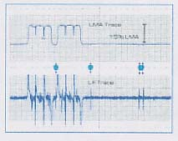
NDT |  | PC computer show the printing
DMT | 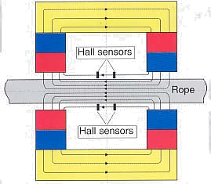 | 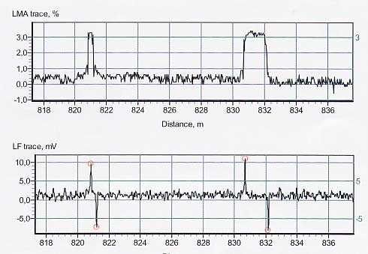  PC computer show the printing
MD | 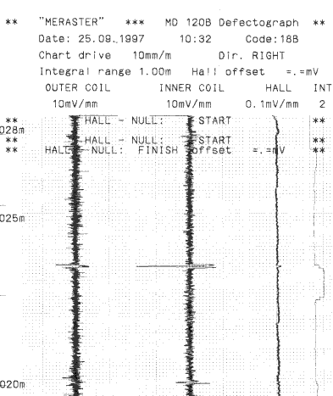  Ditto | 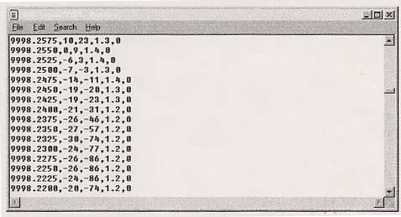  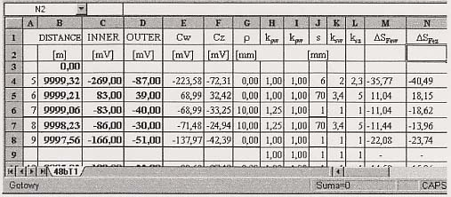  Principal machine show the wave with traditional method  PC show standard equivalence
MTC | 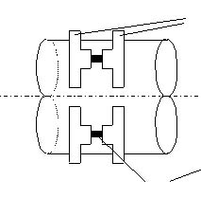  Focus-diffused signal with the magnetic focus ring  The array Hall device will be laminated the sampling  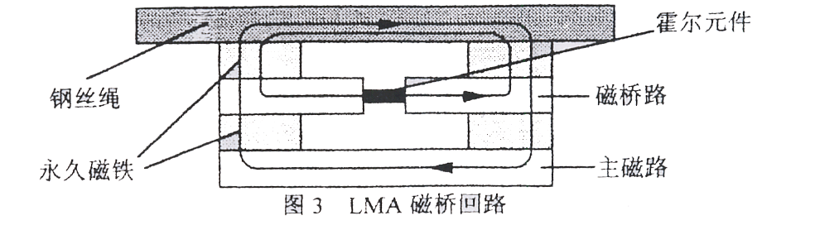  Magnetic bridge way can be quantitatively measured the change of magnetic flux | 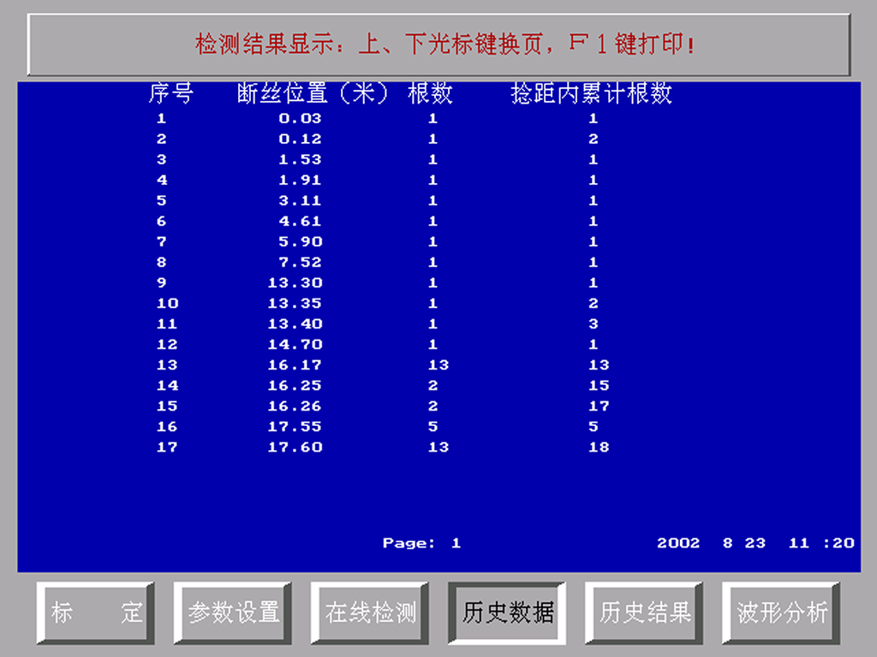  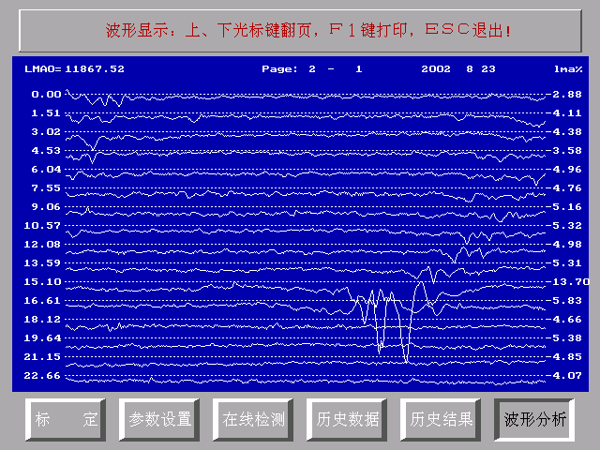  LF the number of broken wire  PC show the quantitative value of thestandard stipulation  LMA the number of percent  Qualitative analyses: loose wire rope, missing wire out of the shape

c. Fig3 The Products disposition in common use and general technological ability Comparison General Comparison
Sys | The Products disposition in common use | The General Technological Ability
NDT | 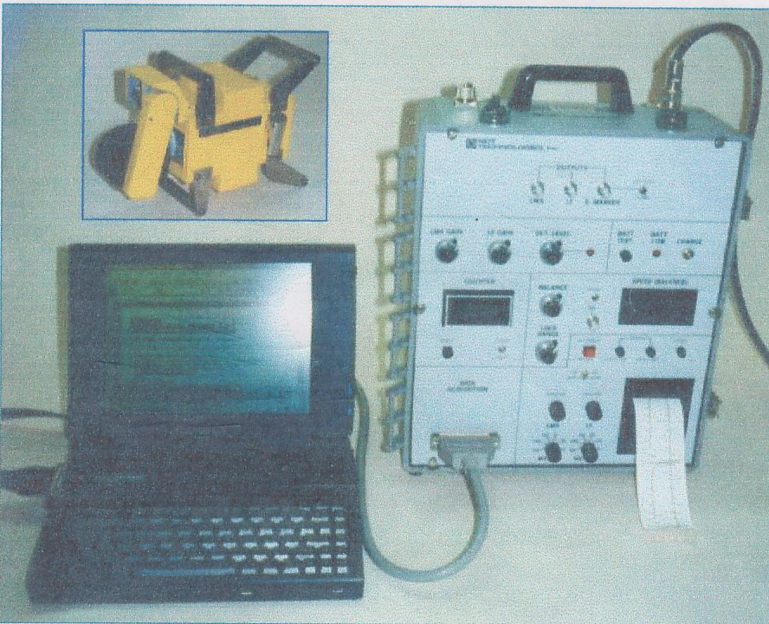 | - The ASTM E1571 Standard in USA is based on the place that NDT Company makes the products. So the products are norm, but test wear and tear for their quantitative only. Do not test broken wire in quantitative. Tiny wire can’t be distinguished.  - The diameter limits are tested 10~76mm only  - There are many testing service nets in the world, but the testing price is very high.  - The weight is about 16~18kg
DMT | 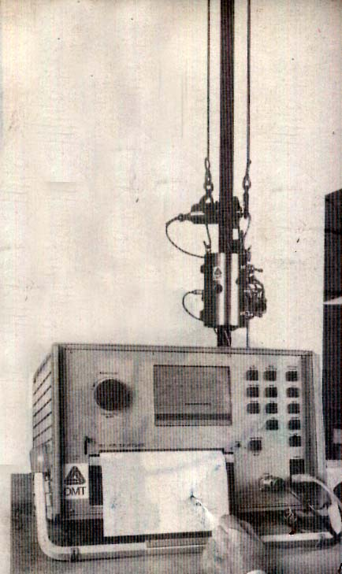  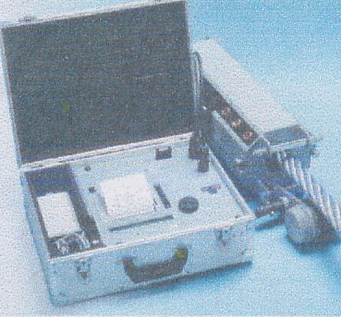 | - Possessing AiSeng Research Institute Support, DMT is better authority. So the price are very expensive.  - The diameter of the products series are tested 8-16mm, and the wire ropes in the suspension bridges and cable-stayed bridges can betested.  - The weight is about 10-15kg
MD |  | - The products have been researched in Poland for many years, but they han’t broken through yet, up to now and the price are very high.  - The diameter of the products series are tested 8-85mm only. They can’t be tested the wire rope for lift/elevator.  - The weight is about
MTC | 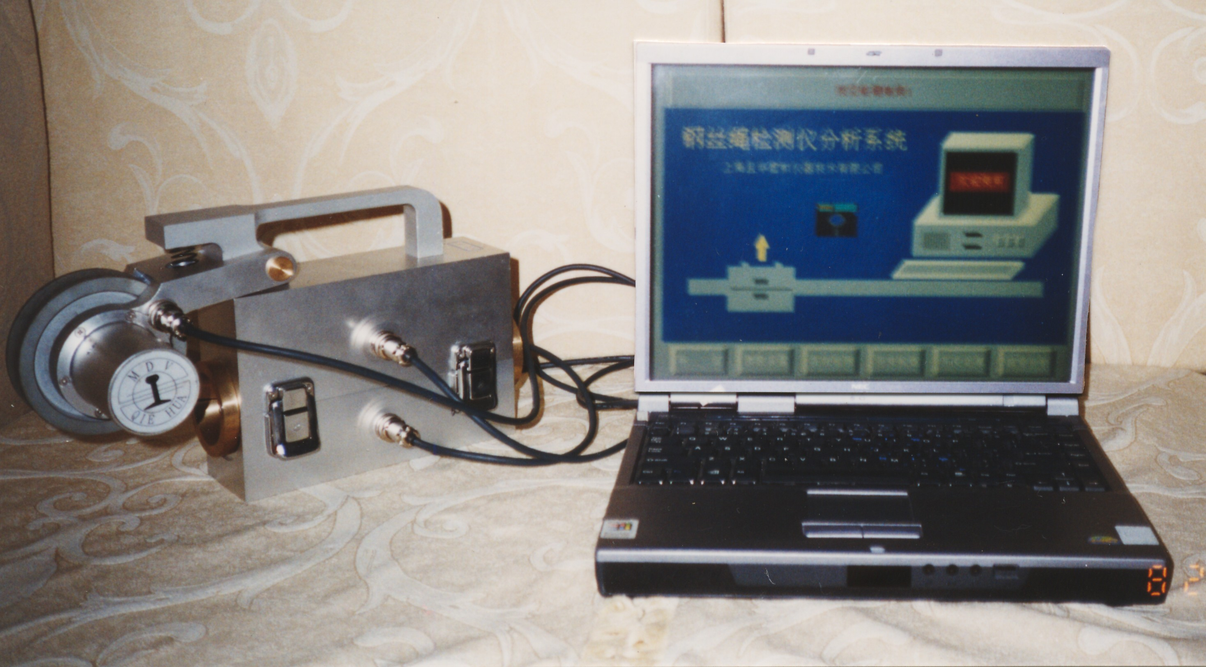 | - Pass computer and specific soft ware and establish math model through calcuation and statistics  - The diameter range 1.5-200mm, the large diameter of plastics and steel cable can be tested in the suspension bridges and cable-stayed bridges.  - The weight is about 3-4kg
C. Theoretical Principle
With development of the computer, the function gets plentiful and plentiful, the speed become fast. Possessing PC computer interpose to collect the sampling and deal with the signal directly. This is a optimistically scheme that prevent from missing testing. But the smallest discrete probability math model must be established.
Theoretical calculation
Experimental testing
Actual application
Real-time disposition
LF

L

LMA

Fig2 Efficient digit model establishment
According to Fig 2 show the efficient digit model is established in Local Fault – LF (broken wire, corrosion etc.) 、Loss of Metallic Cross-Section Area -- LMA (abrasion, the change of the metallic cross-sectional Area, deformation, loose ply etc.) and Length -- L（the sensor pass though the distance and location for wire ropes）three-dimensions space. According to the theoretical calculation, a lot of statistics of testing materials in the laboratory and the various sieving sample, in actual application acquire model of the smallest discrete probability. In view of the fact that the model, namely the method proceed with inverting calculation for the numerical digit signal form the new testing wire flaw. There by obtains the accurate quantitative value of all flaws in wire ropes, a Magnetic Focus Principle, concordance Magnetic leakage.
a. Flux Principle (LF)

Fig 3 The Magnetic focus ring for Magnetic leakage testing of the broken wire
According to Fig 3 show, there are A and B, two magnetic focus ring son each side in convex plat forms. The magnetic focus rings are made of the high permeability magnetic material after specific disposition. They can make magnetic leakage signal that is cause by the flaw of wire ropes concentrate on convex plat forms. Hall devices are special design. It will be of more advantage to magnetic leakage signal focus with less interval distance Δg of convex plat forms, less air clearanceΔg form between two Magnetic focus ring, less two magnetic reluctance. In actual sensor, A and B two magnetic focus rings are multisection array. More hall device form hierarchical composite with deep in magnetic focus rings. This can acquire the same flaw, the same analogy value signal of the inner-outer wire ropes.

b. Magnetic Bridge Return Circuit Concordance Magnetic flux Principle (LMA)
The application LMA of Magnetic flux Principle, if some one adopt testing coil, first make trouble for sensor safety with the coil, first make trouble for sensor safety with the coil demand winding the coil. Second, testing coil sensitivity has something to do with speed of service of the coil of sitting opposite to the wire rope. If someone adopt Hall device testing magnetic field with advantage of uninfluenced by speed and can acquire quantitative value of absolute magnetic field. But when Hall devices are placed in main magnetic circuit testing of the magnetizing wire rope, will not be sensitive for little tiny change of magnetic field with the magnetic induction density very high (in general 0.6~1.0T) and output signal saturation of Hall devices.
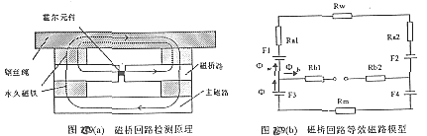

Fig 4a Magnetic Bridge Return Circuit Testing Principle
Fig 4b Equivalent Magnetic Circuit Model in Magnetic Bridge Return Circuit

To put forward to use magnetic bridge return circuit testing principle, Hall devices are placed in Magnetic bridge Circuit to detect the little tiny change of the magnetic induction density in the location of the equilibrium point. (The magnetic induction density in general within ±100mT) and guarantee high sensibility and linear metric, their basal principle, according to Fig.4a and 4b show, the main magnetic circuit and magnetic bridge circuit combined action magnetize the wire rope and reach the saturation level. The influence of magnetic-leakage flux can’t be considered for wire rope and main magnetic circuit with regard to magnetic bridge circuit symmetry. According to magnetic circuit of jier huofu law can be known as:
Φ_{m}=Φ_{w}+Φ_{b}
Φb refer to magnetic flux in magnetic bridge return circuit;
Φm refer to magnetic flux in main magnetic circuit;
Φw refer to magnetic flux in wire rope. There form, quantitative determination percentage of accurate change of the weir rope coss-sectional area can be acquired

D. Practice Applications
Chinese NDT technical levels have reached effectiveness of qualitative determination, quantification, no missing no mistaking. If you decide-the technological parameter in the computer (the calibration of MTC) only once, then you make use of it all the time, under specific circumstance, in accordance with experience you may decide to make use of testing with the computer. The numbers on the screen are shown simple operation. You feel computerize Testing is very simple, easy to learn definitely. The customers that applied the wire ropes had spread all over the trade, and the products and services synchronized into market since 1997, and started into Eurasia area. The following was true example for past six years.
a. Bao Steel Plant
In 1997, the galvanizing product line in press steel plant affiliated BaoShan plant stopped production for imported wire ropes had broken with accident suddenly. The testing company in charge safe equipment purchased MTC immediately, after they have been affirmed with technology, Broken wire never occurred at accident up to now there have been six years.
b. Terminals & Ports wire ropes testing
Wai GaoQiao Harbor Company took the lead in purchasing the suspended wire ropes that MTC test container tyre, six cranes save on 180,000 yuan, the fee for wire ropes in the first year.
Until 2002 the first, second, third, fourth period in Wai GaoQiao harbor, have bought rations series MTC a set of more than 30 totally. This instrument can examine the different diameters wire ropes, such as (that equip container bridge crane, tyre crane, the rigging etc).
Wai GaoQiao, the first period, the first suites of MTC have been tested wire ropes more than 50,000 meters long, while the high strength wear resisting copper conduit are still used yet in 1998.
c. Telpher Cars
The telpher cars accept to testing. The passenger flow number increases rapidly. According to the record. To discover many broken wires, one of then are much more 8 at Alugu cave ropeway in YunNan, 2000. Reaching critical point, so stop the machine to change a new one, in order to avoid an accident. To discover broken wires that tested for JingGangShan purchasing newly and setup just now. Were 5 in 2001, thus demand compensation a piece of wire rope.
- Coal Industries
Coal industry system is due to increase broken wire in accident frequently. In it’s nineties 36 wire ropes testing stations were established. But the accident are still unceasing, the testing stations are given up one after another. Among them, ZhenZhou testing station was the first to purchase MTC, in 2002. This station has been tested online, For all around coal mine/colliery of varying sizes (big or small) with in half a year.
Having accumulated abundant experiences that safety-heck wire rope online. Having assured coalmine safe produce, at the same time, achieved economic benefit greatly.
- Special Devices & Cranes
Shanghai special office are purchase MTC, after they practiced are compared repeatedly, the wire rope testing instrument that Poland, USA developed countries. For mobile crane of Shanghai certain company have taken place the death in accident.
The Labor bureau and the technological superintendent bureau have instructed Shanghai special equipment office proceeded safe testing for 14 mobile crane of this company. Testing over load is use of hanging weight. The wire ropes are tested with the computerized MTC only. The effects are excellent. Finally, the experts from all parts confirm the MTC is a instrument of protagonist, obviously, MTC are not only test the defect of the wire rope but the most importance is that dispose digit signal with computerize technology direct rapidly. Avoided Missing testing.
- Steel cable in suspension bridges and cable-stayed bridges testing
In 1999, Yangtze River three gorges engineering. Introduce the pouring equipment of France large dam. The supporting wire rope with 90mm diameter, 600m long are damaged for transport. The supplier demanded to proceed with safe testing. The supplier is very satisfied with the results of the MTC testing. In 2000, MTC are achieved the experimental testing in Shanghai SongJiang MaoJiang ridge and Shanghai XuPu Bridge successfully.

E. Technical Further Development
a. Radio Remote Control Testing System
With the harbor construction modernization, Chinese Government Ministry of Communication dispatch official documents demand to realize status testing for container crane. Because of development lagging of vibration testing technique, up to now there haven’t been standard norms yet. The customers spend very expensive price, but isn’t practical.
At present there is a American method standard, a Chinese instrument standard and wire rope rejection standard of artificial traditional method testing passed ISO and GB. The development of MTC enters optimistically period.
There is a central computer in the container crane, control and deal with gantry and other information, originally. If the application of current MTC, need drawing long-long wire rope to proceed testing timely is inconvenient. The radio remote control MTC is very important obviously.
b. Compacted wire rope testing
The elevators go up and down system is very typical compacted wire rope installation. When adopting ordinary MTC detect one of the wire ropes, flaw signal that close up to another wire rope must be parastized into the information of the testing wire rope inevitably for the multistrand wire rope dense arrangement, mutual interval 5-7 mm only. After tackling key problem research, application of torpedo isolated magnetic technology for many years, at the beginning of 2001, this technical key problem was solved at last. At present, the products have entered the market.
c. To determine the life span of wire rope
If the flaw of wire ropes is achieved qualitative testing in the two-dimensional space, quantitative testing in three-dimensional space, fixed patterm formed testing of wire ropes are achieved in four-dimensional space necessarily. How about getting on with research work at present? One of them is to pass omnidistance safety coefficient that have reached the flaw testing and stretching force determination calculation at present.
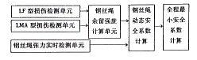

Fig5 Block schematic diagram for safety testing system of the wire ropes
F. Conclusion
During the application of the wire ropes can be suffered from various injuries. This causes the intensity reduction. In view of the fact that the concept and calculation method of real-time testing wire ropes residual strength, can master the intensity status of the wire ropes and calculate out dynamic safety coefficient. Thus reflect safe degree at every stage in the course of working of the wire rope really. The coefficient can help customers ascertain whether need to change the wire ropes. The customers are both can avoid increasing the weight unnecessarily and can ensure to operate safety.

- Acknowledgement
The author is in acknowledgement of Professor Kang YiHua, Doctoral supervisor’s support and encouragement. The author wishes to express his sincere thanks to Shanghai Qiehua Virtual Instrument Technical Co., Ltd and HongKong Makkee International Co., Ltd for popularization of MTC Computerize Magnetic non-distractive wire rope testing and diagnosing system instrument.

H. Reference Literature
- Dong Xinhua Kang Yihua
《The testing technique and practice at service wire ropes》1999年
- Yang Shuzi Kang Yihua
《Quantitative Inspection for Broken wire of wire Ropes Principle》1998年
- Wu Xinjun
《Magnetic Wire Rope Non-distractive testing Principle and Technique》1999年
- Tan Jiwen
《Safety Appraise ment for wire ropes》2002年
- Dong Xinhua Hu Qiang
《Quantitative Inspection for wire ropes in the Elevator Application》2002年
- University of Reading,
6th January 2003
《Wire Rope Survey of Instrument manufacturers》
Offsore technology report – OTO2000 064, 2000

